*Florida International University*

*School of Computing and Information Sciences*

Software Engineering Focus

Feature Document

User Story ID: #710 Design – Gesture Process

**Name:** Filip Klepsa

**Team Member(s):** Lukas Borges, Cristian Cabrera, Hamilton Chevez, Nicolette Celli, Francico Lozada

**Project:** AR-VR-VE for Computer Science (Multimodal Interaction with ASL use case)

**Product Owner(s)**: Francisco Ortega

**Mentor(s)**: Francisco Ortega

**Instructor**: Francisco Ortega, Masoud Sadjadi

**User Story Name: Design – Gesture process**

* Description: **As a** User **I would like** to capture a gesture, save that gesture, replay that gesture, and be able to delete that gesture if needed, **so that** I can use those gestures to create a library of American Sign Language gestures.

Acceptance Criteria

* Implement a way to pull hand vector data from the mini application and save it to a file.
* Design the gesture process for the Leap Motion Controller.
* Design a mock interface for the user.

**Use Case**: **exportJSON**

**Participating Actor:**

* User

**Entry Condition:**

* Actor must have application running and Leap Motion controller plugged in.

**Exit Condition:**

* The save dialog box is closed, the actor is back to the GUI, and the file is saved at the actors chosen location with its given name.

|  |  |
| --- | --- |
| **Actor Steps** | **System Steps** |
| 1. The actor clicks the Export JSON button. |  |
|  | 2. The system prompts the user to select a location to save the file as well as its name. |
| 3. The actor designates a save location and inputs a file name. |  |
|  | 4. The system saves the vector data to the file. |

**Use Case Diagram**

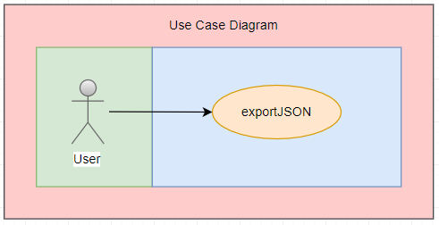

**Sequence Diagram**

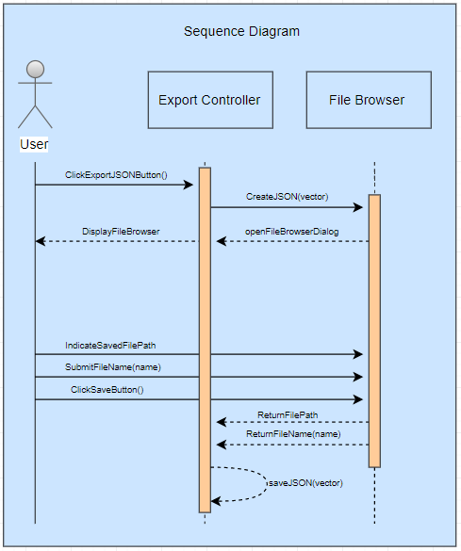

**Class Diagram**

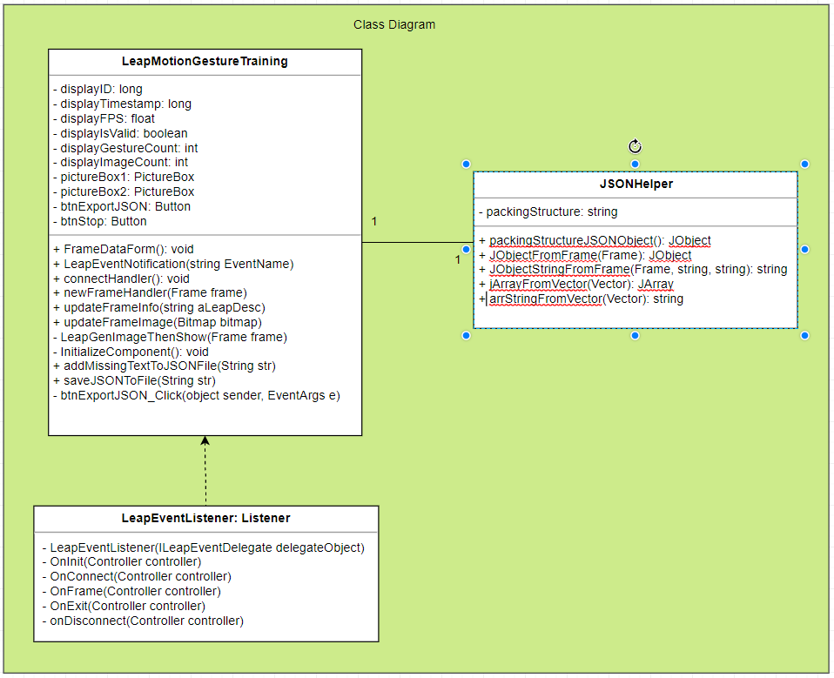

**Unit Test** -Coming Soon

* Test case ID:
* Description/Summary of Test:
* Pre-condition:
* Expected Results:
* Actual Result:
* Status (Fail/Pass):

**Integration Test**

**Visual User Guide**

